

Properties and Structures of Materials

(Organic Chemistry)

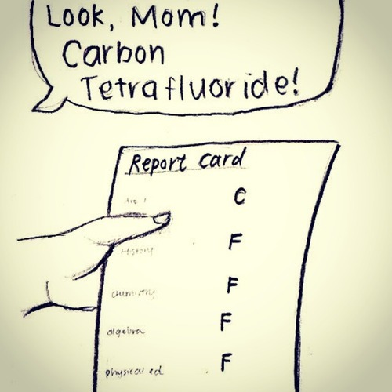

(AceOrganicChem.com n.d.)

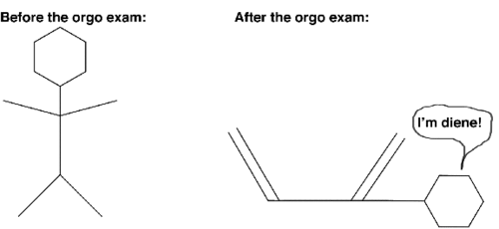

(Arboretictruth 2012)

|  |  |  |  |
| --- | --- | --- | --- |
| **Week** | **Outcomes** | **References and tasks** | **Tasks** |
| **8- 9** | * molecular structural formulae (condensed or showing bonds) can be used to show the arrangement of atoms and bonding in covalent molecular substances * IUPAC nomenclature is used to name straight and simple branched alkanes and alkenes from C1- C8 * hydrocarbons, including alkanes, alkenes and benzene, have different chemical properties that are determined by the nature of the bonding within the molecules | Lucarelli Set 20,  q 1-7  Lucarelli Set 20,  q 11-12  Lucarelli Set 20,  q 8-10, 13-18 |  |
| **T1 w10-**  **T2 w1** | * alkanes, alkenes and benzene undergo characteristic reactions such as combustion, addition reactions for alkenes and substitution reactions for alkanes and benzene | Lucarelli Set 21,  q 1-8 | STAWA  Investigation 46  pg 108:  Reactivity of hydrocarbons  Task 5: Test- Properties and Structure of Materials: Organic Chemistry  (T2: Week 1)  Task 6: Practical test-Post laboratory test 1  (T2: Week 2) |

**Bonding in Organic Compounds**

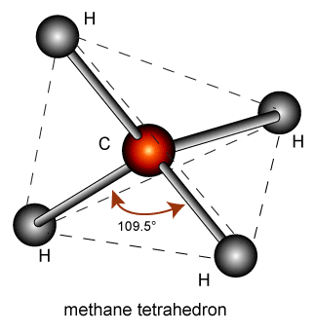In organic compounds, carbon is covalently bonded to other non-metals. Carbon has four valence electrons needing four electrons to achieve a stable octet and so forms four covalent bonds. These bonds can be single, double or triple. For example, the “simplest” organic compound is methane (CH4).

(NA, 2009)

The carbon atom shares one each of its valence electrons with a hydrogen atom. The molecule is actually tetrahedral in shape so as to minimise the repulsion between the four single C-H bonds.

**Hydrocarbons** are molecular compounds containing the elements hydrogen and carbon. They are classified into various families of compounds based on structural similarities. We will study the families of:

* Alkanes
* Alkenes
* Cycloalkanes
* Cycloalkenes
* Benzene based compounds (aromatics)

**Nomenclature (Naming)**

1. Find the longest continuous carbon chain. Choose the stem name based on the number of carbon atoms in the longest continuous carbon chain.

|  |  |
| --- | --- |
| **Number of Carbons** | **Stem Name** |
| One | meth- |
| Two | eth- |
| Three | prop- |
| Four | but- |
| Five | pent- |
| Six | hex- |
| Seven | hept- |
| Eight | oct- |
| Nine | non- |
| Ten | dec- |

1. Number the carbon atoms sequentially so that the principle functional group has the lowest number.

The order of priority of the principle functional groups is (from highest to lowest): alkene; halogen then alkyl groups.

For example: CH3CH2CH=CHCH3 pent-2-ene

1. If there is a substituted group (eg a halogen), number the carbons from the end which gives the lowest number to the substituted group.

For example: CH3CH2CHCH3 2-chlorobutane

C*l*

1. If there is an alkyl group (other carbon atoms not part of the main chain – also called a branch), name this using the stem name for the number of carbons and use the suffix -yl. Put a number in front to indicate which carbon it comes from then write the stem name.

For example: -CH3 methyl-

-CH2CH3 ethyl-

CH3CH2CH2CHCH2CH3 3-ethylhexane

CH2

CH3

CH2CHCH=CHCH3  4-methylpent-2-ene

CH3

1. If there is more than one of a substituted group, write the numbers to indicate which carbon they come off, then follow with the prefix di, tri, tetra, penta, etc, then the branch name and -yl. Always finish with the straight chain name.

For example: CH3CHCH2CHCH2CH3

CH3 CH3 2,4-dimethhylhexane

1. Note that numbers are separated from words by hyphens and numbers are separated from each other by commas. There should be no spaces or capital letters in the name at all (unless it is the beginning of a sentence).
2. If there are different types of alkyl groups in the same chain, again use numbers, and put the alkyl groups in alphabetical order according to the stem name (note: you disregard the numerical prefix when alphabetizing).

For example: CH3CH CH CH CH2CH3

CH3 CH3 CH2

CH3 4-ethyl-2,3-dimethylhexane

1. there are substituted halogens, the same rules apply as for alkyl groups, but use fluoro-, chloro-, bromo- and/or iodo-. Again, substituted groups are named alphabetically.

For example: CH3CH2CH2CHCHCH3

C*l* F 3-chloro-2-fluorohexane

1. If there are alkyl groups and substituted halogens, name the halogens before the alkyl groups. If the lowest numbers occur by counting from either end, number so the halogen gets the lowest number. In the case of a tie between two halogens, the first alphabetically gets the lowest number.

For example: CH3CH CH CH CHCH3

CH3 CH3 C*l* C*l* 2,3-dichloro-4,5-dimethylhexane

1. If there is only one option for a substituted halogen or alkyl groups, do not use numbers.

For example: CH3CHCH3

CH3 methylpropane

CH3CH2C*l* chloroethane

Cycloalkanes

1. The name begins with the prefix cyclo- to distinguish it from straight chain aliphatics.
2. Note the shorthand way of drawing rings, where each corner represents a carbon. It is assumed that the remaining bonds are between the carbon and hydrogen atoms.
3. If there is one substituted group, no numbering is required. If there is more than one, numbering is required.

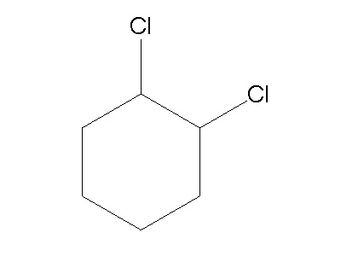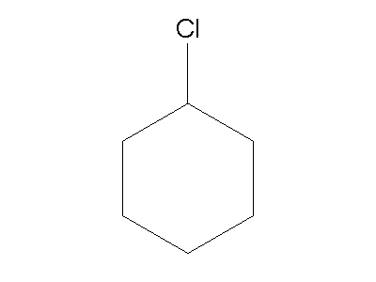

Chlorocyclohexane 1,2-dichlorocyclohexane

Cycloalkenes

1. Cycloalkenes are named similar to the cycloalkanes (ie add the prefix cyclo-) and the double bond is given the lowest number position.

Benzene

1. Benzene and its derivatives are named similar to cyclic hydrocarbons, but ending with the suffix –benzene.

**Alkanes**

Alkanes are **saturated**, they contain only **single bonds** between carbon atoms.

|  |  |  |  |
| --- | --- | --- | --- |
| Name | Molecular formula | Structural formula | Condensed formula |
|  | C2H6 |  |  |
| Butane |  |  |  |
|  |  |  | CH3CH(CH3)CH2CH3 |
|  |  | http://everythingmaths.co.za/science/grade-12/04-organic-molecules/pspictures/8a605e061eeb6915050b9568b2a45ad4.png |  |

Alkanes: Structural isomerism

Structural isomers are compounds having the same molecular formula but different structural formula.

Draw the three structural isomers of C5H12. Name them and write their condensed formula.

**Alkenes**

Alkenes contain a **double bond** between carbon atoms and so are **unsaturated**.

|  |  |  |  |
| --- | --- | --- | --- |
| Name | Molecular formula | Structural formula | Condensed formula |
|  | C2H4 |  |  |
|  |  |  | CH3CH2CHCHCH3 |
| 3,4-diethylhex-1-ene |  |  |  |
|  |  |  |  |

Alkenes: Geometric (cis-trans) isomerism

Geometric isomers have the same molecular and structural formula but a different geometry. The different geometry is a result of the inability of double bonded carbon atoms to rotate along the axis of their double bond.

Draw the **cis** and **trans** isomers of but-2-ene.

**Cycloalkanes**

|  |  |  |  |
| --- | --- | --- | --- |
| Name | Molecular formula | Structural formula | Condensed formula |
|  |  |  | CH2CH2CH2 |
| 1,2-dichlorocyclohexane |  |  |  |
|  |  | http://img1.guidechem.com/chem/e/dict/90/1556-18-9.jpg |  |

**Cycloalkenes**

|  |  |  |  |
| --- | --- | --- | --- |
| Name | Molecular formula | Structural formula | Condensed formula |
|  |  |  | CHCHCH2 |
| 4-chlorocyclohexene |  |  |  |
|  |  | http://www.chem.purdue.edu/gchelp/molecules/cycbute.gif |  |

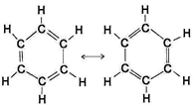**Benzene compounds- aromatics**

These are the hydrocarbons containing the benzene ring.

The benzene ring has the formula C6H6 and is particularly stable.

Due to the arrangement of its electrons, the benzene ring is represented as follows:

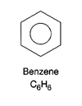

|  |  |  |  |
| --- | --- | --- | --- |
| Name | Molecular formula | Structural formula | Condensed structural formula |
| methylbenzene |  |  |  |
|  |  |  | (CH)3CClCHCCl |
|  |  | http://www.chemsynthesis.com/molimg/1/big/14/14584.gif |  |

**Physical Properties of Hydrocarbons**

1. **Melting and Boiling Points**
2. **Solubility**

**Chemical Properties of Hydrocarbons**

1. **Addition**

As alkenes are unsaturated, they have the capacity to bond to more atoms. They are therefore more reactive than alkanes and readily undergo addition reactions.

Use condensed structural formula to show the addition reactions for:

1. Pent-1-ene + hydrogen
2. Pent-1-ene + fluorine
3. Pent-1-ene + Hydrogen chloride
4. **Substitution**

Substitution reactions occur when an alkane or benzene is combined with another element. The C-H bond breaks and the hydrogen is substituted with another element which requires one bond, for example a halogen.

The reactions tend to be slow with one substitution at a time and they require UV light as a catalyst.

Use condensed structural formula to show the substitution reactions for:

1. Ethane + bromine (first substitution)
2. Methane + chlorine (complete substitution)
3. Benzene + Cl2
4. **Combustion**

Hydrocarbons are excellent fuels. When ignited in excess air (O2) they produce carbon dioxide and water vapour and also release considerable amounts of heat energy. This is called complete combustion.

Use molecular formula to write balanced chemical equations for the following combustion reactions (assume complete combustion):

1. Methane in air
2. Butane in air

**Incomplete combustion** will occur if the air (O2) supply is limited. Carbon monoxide and even soot (solid carbon) can be produced.

Use molecular formula to write balanced chemical equations for the following reactions where incomplete combustion occurs:

1. Methane in limited oxygen
2. Butane in limited oxygen

# Bibliography

AceOrganicChem.com. *One more organic chemistry joke.* n.d. http://www.aceorganicchem.com/blog/2013/10/04/one-organic-chemistry-joke/ (accessed March 16, 2015).

Arboretictruth. *Nerd Humour.* 13 June 2012. https://arboretictruth.wordpress.com/2012/06/13/nerd-humor/ (accessed March 16, 2015).

NA. (2009). *The Conformation and Configuration of Polymer Molecules*. Retrieved October 10th, 2009, from Beechmont Crest